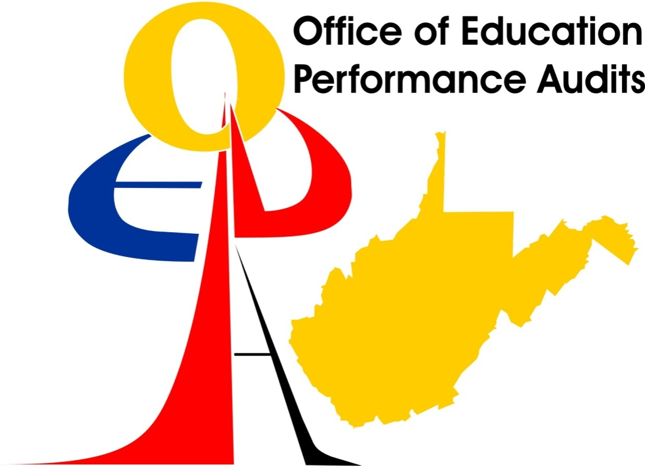

Draft Education Performance Audit Report
For
LIBERTY HIGH SCHOOL
Harrison County School System

May 2008

West Virginia Board of Education

Page
Introduction 2
Education Performance Audit Team 2
School Performance 3
Annual Performance Measures for Accountability 6
Education Performance Audit 10
Initiatives for Achieving Adequate Yearly Progress 10
High Quality Standards 11
Indicators of Efficiency 12
Building Capacity to Correct Deficiencies 13
Identification of Resource Needs 14
Early Detection and Intervention 16
School Accreditation Status 17

INTRODUCTION
An announced Education Performance Audit of Liberty High School in Harrison County was conducted on March 12, 2008. The review was conducted at the specific direction of the West Virginia Board of Education. The purpose of the review was to investigate the reasons for performance and progress that are persistently below standard and to make recommendations to the school and school system, as appropriate, and to the West Virginia Board of Education on such measures as it considers necessary to improve performance and progress to meet the standard.

The Education Performance Audit Team reviewed the Five-Year Strategic Improvement Plan, interviewed school personnel and school system administrators, observed classrooms, and examined school records. The review was limited in scope and concentrated on the subgroups that failed to achieve adequate yearly progress (AYP).

EDUCATION PERFORMANCE AUDIT TEAM

Office of Education Performance Audits Team Chair – Allen D. Brock, Coordinator
West Virginia Department of Education Team Leader for Technology – Kathy Boone, Assistant Director, Office of Instructional Technology
West Virginia Department of Education Team Leader – Shelly Stalnaker, Coordinator, Office of Healthy Schools

TEAM MEMBERS
Name | Title | School/County
Athanasia P. Butcher | High School Principal | Gilmer County High School  Gilmer County
Karen D. Church | High School Principal | Clay-Battelle High School  Monongalia County
Joseph A. Starcher | Vocational Director | Brooke High School  Brooke County
David S. Tupper | High School Principal | Spencer High School  Roane County
Thomas N. Wood | High School Principal | John Marshall High School  Marshall County
Elizabeth K. Zuchowski | Middle School Assistant Principal | Monongalia County

SCHOOL PERFORMANCE

33 HARRISON COUNTY
Dr. Carl H. Friebel, Jr., Superintendent
502 LIBERTY HIGH SCHOOL – Passed
Dennis Zahradnik, Principal
Grades 09 - 12
Enrollment 641 (2005-2006 2nd month enrollment report)
WESTEST 2005-2006
Group | Number Enrolled for FAY | Number Enrolled on Test Week | Number Tested | Participation  Rate | Percent Proficient | Met Part. Rate Standard | Met Assessment Standard | Met Subgroup Standard
Mathematics
All | 149 | 158 | 154 | 97.46 | 70.27 | Yes | Yes
White | 141 | 146 | 143 | 97.94 | 71.42 | Yes | Yes
Black | ** | ** | ** | ** | ** | NA | NA | NA
Hispanic | * | * | * | * | * | * | * | *
Indian | * | * | * | * | * | * | * | *
Asian | ** | ** | ** | ** | ** | NA | NA | NA
Low SES | 77 | 85 | 81 | 95.29 | 64.47 | Yes | Yes
Spec. Ed. | 21 | 22 | 21 | 95.45 | 23.80 | NA | NA | NA
LEP | * | * | * | * | * | * | * | *
Reading/Language Arts
All | 149 | 158 | 154 | 97.46 | 73.64 | Yes | Yes
White | 141 | 146 | 143 | 97.94 | 74.28 | Yes | Yes
Black | ** | ** | ** | ** | ** | NA | NA | NA
Hispanic | * | * | * | * | * | * | * | *
Indian | * | * | * | * | * | * | * | *
Asian | ** | ** | ** | ** | ** | NA | NA | NA
Low SES | 77 | 85 | 81 | 95.29 | 61.84 | Yes | Confidence Interval
Spec. Ed. | 21 | 22 | 21 | 95.45 | 19.04 | NA | NA | NA
LEP | * | * | * | * | * | * | * | *
FAY -- Full Academic Year
* -- 0 students in subgroup
** -- Less than 10 students in subgroup
Passed
Graduation Rate = 85.5%

SCHOOL PERFORMANCE
This section presents the Annual Performance Measures for Accountability and the Education Performance Audit Team’s findings.
33 HARRISON COUNTY
Dr. Carl H. Friebel, Jr., Superintendent
502 LIBERTY HIGH SCHOOL – Needs Improvement
Dennis Zahradnik, Principal
Grades 09 - 12
Enrollment 625 (2006-2007 2nd month enrollment report)
WESTEST 2006-2007
Group | Number Enrolled for FAY | Number Enrolled on Test Week | Number Tested | Participation  Rate | Percent Proficient | Met Part. Rate Standard | Met Assessment Standard | Met Subgroup Standard
Mathematics
All | 148 | 153 | 150 | 98.03 | 55.86 | Yes | Averaging
White | 144 | 149 | 146 | 97.98 | 56.02 | Yes | Averaging
Black | ** | ** | ** | ** | ** | NA | NA | NA
Hispanic | ** | ** | ** | ** | ** | NA | NA | NA
Indian | * | * | * | * | * | * | * | *
Asian | * | * | * | * | * | * | * | *
Low SES | 75 | 80 | 77 | 96.25 | 41.66 | Yes | Confidence Interval - Averaging
Spec. Ed. | 28 | 30 | 30 | 100.00 | 3.57 | NA | NA | NA
LEP | ** | ** | ** | ** | ** | NA | NA | NA
Reading/Language Arts
All | 148 | 153 | 152 | 99.34 | 67.34 | Yes | Confidence Interval
White | 144 | 149 | 148 | 99.32 | 67.13 | Yes | Confidence Interval
Black | ** | ** | ** | ** | ** | NA | NA | NA
Hispanic | ** | ** | ** | ** | ** | NA | NA | NA
Indian | * | * | * | * | * | * | * | *
Asian | * | * | * | * | * | * | * | *
Low SES | 75 | 80 | 79 | 98.75 | 52.70 | Yes | No
Spec. Ed. | 28 | 30 | 30 | 100.00 | 28.57 | NA | NA | NA
LEP | ** | ** | ** | ** | ** | NA | NA | NA
FAY -- Full Academic Year
* -- 0 students in subgroup
** -- Less than 10 students in subgroup
Passed
Graduation Rate = 82.1%
Adequate Yearly Progress (AYP) Information by Class
Mathematics
Class | Tested  Enr. | FAY  Enr. | Tested | FAY  Tested | Part.  Rate | Novice | Below  Mastery | Mastery | Above  Mastery | Distinguished | Proficient
10 | 153 | 148 | 150 | 145 | 98.04 | 16.55 | 27.59 | 40.00 | 13.79 | 2.07 | 55.86

Reading
Class | Tested  Enr. | FAY  Enr. | Tested | FAY  Tested | Part.  Rate | Novice | Below  Mastery | Mastery | Above  Mastery | Distinguished | Proficient
10 | 153 | 148 | 152 | 147 | 99.35 | 12.93 | 19.73 | 40.82 | 19.05 | 7.48 | 67.35

Enr. - Enrollment
FAY - Full Academic Year
Part. - Participation

Other Relevant Performance Data
2006-2007 Writing Assessment

Distribution of Performance Across All Performance Levels
Grade 10 | Total # Tested | % At Distinguished | % At Above Mastery | % At Mastery | % At Partial Mastery | % At Novice | % With No Score | % of Students at or Above Mastery | % of Students Below Mastery
State – WV | 19327 | 8 | 29 | 50 | 11 | 2 | 1 | 87 | 13
Harrison County | 763 | 5 | 22 | 58 | 12 | 1 | 2 | 85 | 15
Liberty High | 150 | 3 | 17 | 55 | 19 | 2 | 5 | 75 | 25

ANNUAL PERFORMANCE MEASURES FOR ACCOUNTABILITY

Below Standard

5.1.1. Achievement.
This is the 1st year that Liberty High School failed to achieve adequate yearly progress (AYP) in one or more subgroups designated in 5.1.1. Achievement. Liberty High School failed to achieve AYP in the economically disadvantaged (SES) subgroup in reading/language arts. The school achieved AYP in the all students (AS) and the racial/ethnicity white (W) subgroups in mathematics and reading/language arts only by application of the confidence interval and/or averaging, and in the SES subgroup in mathematics by application of the confidence interval/averaging. It is further noted that the special education (SE) subgroup with the number (N) less than 50, scored far below the State’s percent proficient level in mathematics and reading/language arts.
The county curriculum staff and school staff were addressing these subgroups in the county and school Five-Year Strategic Plans and applying interventions to improve achievement of all students.

Adequate Yearly Progress (AYP) Information by Class data indicated scores below mastery in both mathematics and reading: Grade 10 – 44.14 percent in mathematics and 32.66 percent in reading. These scores have implication for the Five-Year Strategic Plan and school improvement.

Results from the 2006-2007 West Virginia Statewide Writing Assessment revealed a deficiency at Grade 10. West Virginia had 87 percent of the students at or above mastery compared to 85 percent for Harrison County and 75 percent for Liberty High School. The school must continue to address this issue through a schoolwide instruction in writing approach and assure that all teachers provide appropriate feedback to all students on a minimum of a weekly basis.
The following professional development and/or training opportunities were provided as reported by the principal.
- Five-Year Strategic Plan Update.
- ACT EXPLORE Workshop.
- Autism Training.
- Best Standards-Based Technology Integration Practices for 21st Century.
- Co-Teaching.
- Crisis Prevention Interventions.
- Curriculum Mapping – Alignment of West Virginia Content Standards and Objectives (CSOs) in Mathematics and Reading/Language Arts.
- Developing Quality Individualized Education Plans (IEPs).
- Hyperactivity/Attention Deficit Disorder.
- Instructional Strategies.
- Memory, Learning, and the Brain.
- Mentor Training.
- Positive Behavior Support (PBS).
- Peer Mediation Training.
- Raising the Rigor: Teaching Strategies to Use in High School English.
- Read Like a Writer! Write Like a Reader!
- Reading in Content Areas.
- Safe and Drug Free Schools.
- Standards Based Mathematics.
- Summer Science/Mathematics Teachers Academy.
- Visually Impaired in the Classroom.
- Walk for Health.
- WESTEST Data Disaggregation.
- Worksheets Don’t Grow Dendrites.
- Various Special Education Seminars.
- Various Administrator Workshops.

NUMBER OF ADVANCED PLACEMENT (AP), HONORS, AND
COLLEGE COURSES OFFERED
2007-2008
High School | Number of AP Courses Offered | Number of Honors Courses Offered | Number of College Credit Courses Offered
Liberty High | 3 | 3 | 6
The following Advanced Placement (AP) courses were offered at Liberty High School during the 2007-08 school year.
AP Calculus – 11 students enrolled.
AP French – 0 students enrolled.
AP Studio Art – 3 students enrolled.
The following honors courses were offered at Liberty High School during the 2007-08 school year.
Honors English 9
Honors English 10
Honors English 11
Students were enrolled in the following college level courses taught at Fairmont State University during the 2007-08 school year.
English (both Fall and Spring semesters)
Psychology
Sociology
Folklore
Italian
ADVANCED PLACEMENT TEST (APT) (COLLEGE BOARD)
Liberty High | 2002-03 | 2003-04 | 2004-05 | 2005-06
10th Grade Test Takers (%) | 0.0 | 0.0 | 0.0 | 0.0
11th Grade Test Takers (%) | 0.0 | 0.0 | 0.0 | 0.0
12th Grade Test Takers (%) | 2.9 | 0.0 | 0.0 | 0.0
10th Grade Test Takers (%) with a score of 3 or higher | *NA | *NA | *NA | *NA
11th Grade Test Takers (%) with a score of 3 or higher | *NA | *NA | *NA | *NA
12th Grade Test Takers (%) with a score of 3 or higher | 75.0 | 0.0 | 0.0 | 0.0
*NA – Not Available.
The guidance counselor provided the following data of the 2006-07 Advanced Placement (AP) Test data. In 2006-07 16 sixteen students were enrolled in AP Calculus; no one took the AP exam. One student was enrolled in AP French and one student took the AP exam. Three students were enrolled in AP Studio Art; one student took the AP exam and scored 3 or higher.
ESTIMATED COLLEGE GOING RATE
FALL 2006
 | Number of High School Graduates  2005-06 | Overall College Going Rate
State | 17,441 | 58.3%
Liberty High | 130 | 63.1%
Source: West Virginia College Going Rates By County and High School Fall 2006,
West Virginia Higher Education Policy Commission.
Liberty High School’s Fall 2006 overall college going rate of 63.1 percent was higher than West Virginia’s overall college going rate of 58.3 percent.
HIGH SCHOOL GRADUATES ENROLLED IN DEVELOPMENTAL COURSE
FALL 2005
 | % in Developmental Mathematics | % in Developmental English | % in Any Developmental Course(s)
State | 30.3% | 15.6% | 34.1%
Liberty High | 29.6% | 11.4% | 31.8%
Source: Performance of High School Graduates Enrolled in Public Colleges and Universities, Fall 2005. (December 2006) West Virginia Higher Education Policy Commission.

The percent of Liberty High School’s students enrolled in developmental mathematics (29.6 percent) was slightly less than West Virginia’s rate (30.3 percent). The percent of Liberty High School’s students enrolled in developmental English courses at 11.4 percent was 4.2 percent less than the State’s rate (15.6 percent) and the percent of Liberty High School’s students enrolled in any developmental course at 31.8 percent was less than the State’s 34.1 percent.

EDUCATION PERFORMANCE AUDIT

INITIATIVES FOR ACHIEVING ADEQUATE YEARLY PROGRESS

The Education Performance Audit Team reported that Liberty High School had undertaken initiatives for achieving Adequate Yearly Progress (AYP). The prominent initiatives and activities included the following.

7.1.1. Curriculum based on content standards and objectives. The staff demonstrated extensive knowledge of the West Virginia Content Standards and Objectives (CSOs). Numerous students were articulate about the CSOs and how the teachers were addressing them. It was evident that the CSOs were highly important and being used in all classrooms.
7.1.3. Learning environment. Students reported that they felt safe and that the staff valued them. All students interviewed indicated that adults were available and that they were approachable if a problem or an issue arose that they needed to discuss. The educational atmosphere was well organized and stimulating and the faculty was extremely concerned about the students’ education.

HIGH QUALITY STANDARDS

Necessary to Improve Performance and Progress.

7.7. Safe, Drug Free, Violence Free, and Disciplined Schools
7.7.2. Policy implementation. The county and schools implement: a policy governing disciplinary procedures; a policy for grading consistent with student confidentiality; policies governing student due process rights and nondiscrimination; the Student Code of Conduct policy; the Racial, Sexual, Religious/Ethnic Harassment, and Violence policy; an approved policy on tobacco use; an approved policy on substance abuse; and an approved policy on AIDS Education. (W.Va. Code §18A-5-1 and §18-8-8; Policy 2421; Policy 2422.4; Policy 2422.5; Policy 4373; Policy 2515)
Smokeless tobacco use was evident in the male rest rooms on the first and second floors.

Indicators of Efficiency
Indicators of efficiency for student and school system performance and processes were reviewed in the following areas: Curriculum delivery, including but not limited to, the use of distance learning; facilities; administrative practices; personnel; utilization of regional education service agency, or other regional services that may be established by their assigned regional education service agency. This section contains indicators of efficiency that the Education Performance Audit Team assessed as requiring more efficient and effective application.

The indicators of efficiency listed are intended to guide Liberty High School in providing a thorough and efficient system of education. Harrison County is obligated to follow the Indicators of Efficiency noted by the Team. Indicators of Efficiency shall not be used to affect the approval status of Harrison County or the accreditation status of the schools.
8.1.1. Curriculum. The school district and school conduct an annual curriculum audit regarding student curricular requests and overall school curriculum needs, including distance learning in combination with accessible and available resources.
While test results had declined sharply from the 2005-2006 to the 2006-2007 WESTEST, it was evident that the entire staff was well aware of the students’ needs and had taken action to address the deficiencies. Numerous staff development sessions had been conducted that specifically targeted the instructional strategies that will have a positive impact on student achievement. The Team observed high quality instruction in all classrooms and all students interviewed stated that the staff was concerned about their education and taking measures to increase achievement.

Building Capacity to Correct Deficiencies
West Virginia Code §18-2E-5 establishes that the needed resources are available to assist the school or school system in achieving the standards and alleviating the deficiencies identified in the assessment and accountability process. To assist Liberty High School in achieving capacity, the following resources are recommended.

HIGH QUALITY STANDARDS | RECOMMENDED RESOURCES
7.7.2. Policy implementation. | West Virginia Department of Education  Office of Healthy Schools  (304) 558-8830

18.1. Capacity building is a process for targeting resources strategically to improve the teaching and learning process. School and county electronic strategic improvement plan development is intended, in part, to provide mechanisms to target resources strategically to the teaching and learning process to improve student, school, and school system performance.
The Team determined that Liberty High School and Harrison County have the capacity to improve student achievement. The Team recommended that the administrator investigate and implement a tobacco cessation program to combat the tobacco use.

Identification of Resource Needs
A thorough and efficient system of schools requires the provision of an adequate level of appropriately managed resources. The West Virginia Board of Education adopted resource evaluation as a part of the accreditation and evaluation process. This process is intended to meaningfully evaluate the needs for facilities, personnel, curriculum, equipment and materials in each of the county’s schools and how those impact program and student performance.
19.1. Facilities, equipment, and materials. Facilities and equipment specified in Policy 6200, Chapters 1 through 14, are available in all schools, classrooms, and other required areas. A determination will be made by using the Process for Improving Education (W.Va. Code §18-2E-5) whether any identified deficiencies adversely impact and impair the delivery of a high quality educational program if it is below the West Virginia Board of Education standards due to inadequacies or inappropriate management in the areas of facilities, equipment, and materials. The Education Performance Audit Teams shall utilize an assessment instrument for the evaluation of school facilities which generally follows the requirements of Policy 6200. Note: Corrective measures to be taken in response to any identified resource deficiency will of necessity be subject to the feasibility of modifying existing facilities, consideration of alternative methods of instructional delivery, availability of funding, and prioritization of educational needs through Comprehensive Educational Facilities Plans and the West Virginia School Building Authority. This policy does not change the authority, judgment, or priorities of the School Building Authority of West Virginia who is statutorily responsible for prioritizing “Need” for the purpose of funding school improvements or school construction in the State of West Virginia or the prerogative of the Legislature in providing resources. (Policy 6200 and Tomblin v. Gainer)

According to the items checked in the School Facilities Evaluation Checklist, the school was below standard in the following areas. The principal checked and the Team confirmed the following school facility resource needs.

19.1.10. Specialized instructional areas. The art facility did not have black-out areas. The music facilities did not have acoustical treatment.
19.1.11. Grades 6-12 science facilities. All science facilities did not have the following: Gas, vacuum, fume hood, emergency showers, blanket, main gas shut-off, AC current, chairs and desks.
19.1.12. Grades 7-12 auditorium/stage. The high school auditorium did not have space for an orchestra and was not acoustically treated.
19.1.15. Health service units. A health services unit of adequate size was not provided. The following equipment and furnishings were not available: Curtained or small rooms with cots, scales, refrigerator with locked storage, and a work counter.

Early Detection and Intervention
One of the most important elements in the Education Performance Audit process is monitoring student progress through early detection and intervention programs.

Given the proactive approach that the school had taken and the high quality staff development that had been implemented, the Team believed that student achievement will increase. The administration must continue to monitor and evaluate the effectiveness of each program and make necessary changes to assure program effectiveness. It was evident that student achievement was a high priority and that the administration and all staff were striving to give all students access to high quality instruction.
School Accreditation Status
School | Accreditation Status | Education Performance Audit High Quality Standards | Annual Performance Measures Needing Improvement | Date Certain
33-502 Liberty High | Full  Accreditation | 7.7.2

Education Performance Audit Summary

The Team identified one high quality standard necessary to improve performance and progress. The Team noted an indicator of efficiency, offered capacity building resources, and noted an early detection and intervention comment.
Liberty High School’s Education Performance Audit was limited in scope to the performance and progress standards related to student and school performance. The Team also conducted a resource evaluation to assess the resource needs of the school. The Team submits this draft report to guide Liberty High School in improvement efforts. The school and county have until the next accreditation cycle to correct the deficiency noted in the report pursuant to W.Va. Code §18-2E-5 (n) School accreditation. (1).

